SDLC Models Documentation

1. Introduction
Software Development Life Cycle (SDLC) consists of several structured models that guide the planning, designing, developing, and maintaining of software systems.
Different models follow different approaches based on project needs, requirement stability, team size, and risk levels.
This document explains four major SDLC models in detail:
Waterfall Model
Agile Model
V-Model (Verification & Validation Model)
Spiral Model
Each model includes:
Definition
Phases
Advantages
Limitations
Real-world example

2. Waterfall Model

2.1 Definition
The Waterfall Model is a linear and sequential SDLC model where each phase must be completed before the next one begins.
It is one of the oldest and simplest SDLC models.

2.2 Phases
Requirement Analysis – All requirements are gathered at the beginning.
System Design – Architecture and design documents are created.
Implementation – Developers write code according to the design.
Testing – The entire application is tested after development.
Deployment – Product is delivered to the customer.
Maintenance – Fixes and updates after deployment.

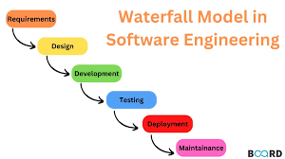

2.3 Advantages
Simple and easy to understand
Works well for small projects
Clear documentation at every phase
Good for projects with fixed, stable requirements

2.4 Limitations
Very rigid; changes cannot be made easily
Testing happens late, increasing risk
Not suitable for complex or evolving projects
Delayed feedback from users

2.5 Real-World Example
Example: Government project for issuing driving licenses
Government requirements are fixed, and changes are minimal.
Once finalized, the system can be developed step-by-step.

3. Agile Model

3.1 Definition
The Agile Model is an iterative and incremental SDLC approach where software is built and improved in small cycles called sprints.
Customer feedback is taken frequently, and changes can be made anytime.

3.2 Key Concepts
Sprints: Small development cycles (2–4 weeks)
Scrum Meetings: Daily stand-up meetings
Product Backlog: List of tasks/features to be implemented
Incremental Releases: Software delivered in small parts

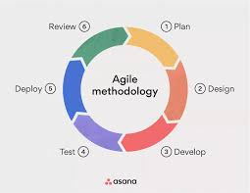

3.3 Advantages
Highly flexible
Rapid delivery of working software
Continuous feedback from the client
Reduced risk due to iterative development
Great for uncertain or changing requirements

3.4 Limitations
Requires experienced and disciplined teams
Hard to predict project cost and timeline
Extensive communication needed
Documentation may be less detailed

3.5 Real-World Example
Example: Mobile App Development (e.g., Zomato, Swiggy)
New features, frequent updates, and customer feedback make Agile ideal.

4. V-Model (Verification & Validation Model)

4.1 Definition
The V-Model is an SDLC model where each development phase has a corresponding testing phase.
It is also called the Validation and Verification Model.
The structure looks like a “V” shape:
Left Side → Verification (Design/Development)
Right Side → Validation (Testing)

4.2 Phases

Verification Phases (Left arm of V)
Requirement Analysis – Corresponds to Acceptance Testing
System Design – Corresponds to System Testing
Architecture Design – Corresponds to Integration Testing
Module Design – Corresponds to Unit Testing

Validation Phases (Right arm of V)
Unit Testing
Integration Testing
System Testing
Acceptance Testing

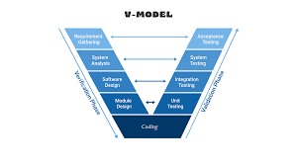

4.3 Advantages
Very high quality due to early testing focus
Clear mapping between development and testing stages
Good for large, mission-critical projects
Errors can be caught early

4.4 Limitations
Not flexible for requirement changes
Expensive if changes occur late
Requires strong documentation and planning

4.5 Real-World Example
Example: Banking software (ATM system, Loan processing system)
These applications require high reliability and strict testing.

5. Spiral Model

5.1 Definition
The Spiral Model combines features of the Waterfall Model and iterative development.
It emphasizes risk analysis and is used for large, high-risk projects.
Each spiral iteration consists of four activities:

5.2 Phases
Planning – Identify objectives, constraints
Risk Analysis – Analyze and reduce risks
Development & Testing – Build the prototype or software
Evaluation – Client reviews the output
The process repeats until the software is complete.

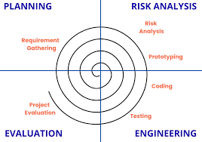

5.3 Advantages
Best model for high-risk, complex projects
Incorporates customer feedback
Continuous risk assessment
Flexible and scalable

5.4 Limitations
Very expensive
Requires experienced teams
Not suitable for small projects
Complex model to manage

5.5 Real-World Example
Example: Large defense or aerospace systems (missile control, aircraft simulation)
These projects involve high risks, prototypes, and safety-critical systems.

6. Summary Comparison Table
Model | Flexibility | Cost | Risk Management | Suitable For
Waterfall | Low | Low | Low | Small projects with fixed requirements
Agile | Very High | Medium | Medium | Apps, evolving projects, startups
V-Model | Low | High | High | Banking, medical, critical systems
Spiral | High | Very High | Very High | Large, risky, complex systems

7. Conclusion
Understanding SDLC models helps in selecting the right approach for software development.
Each model has unique strengths:
Waterfall → Simple and structured
Agile → Fast, flexible, customer-driven
V-Model → Ensures thorough testing
Spiral → Best for high-risk, large projects

